**1.Created EC2 instance for Terraform creation**

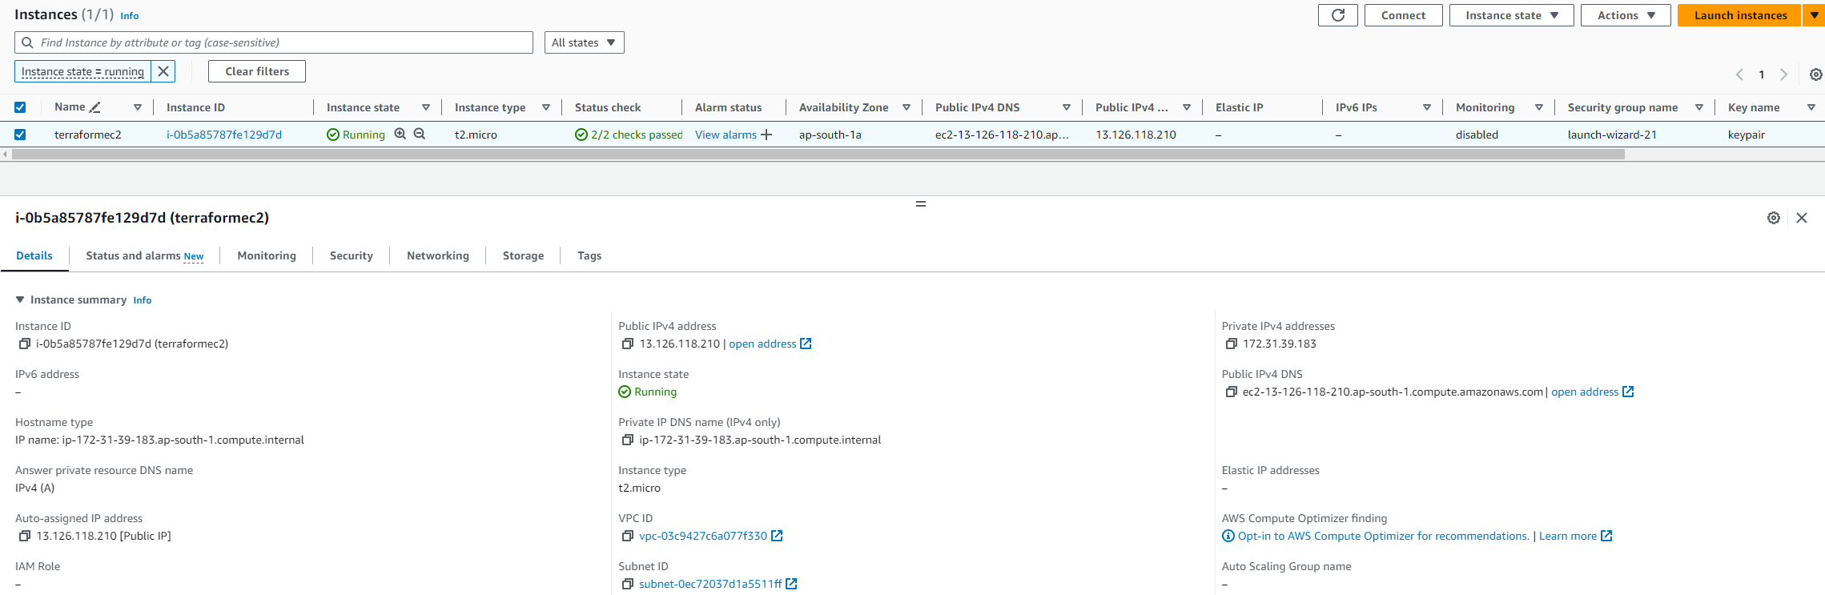

**2.EC2 Launched terraform & AWS CLI installed and configured in the EC2 machine**

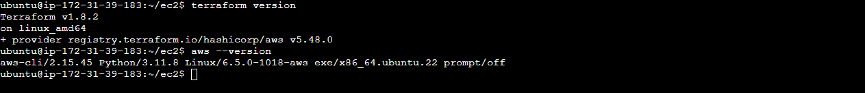

**3.Creating terraform script file**



**4.Terraform Script File for Launching 2 EC2 in 2 Regions with Nginx App.**

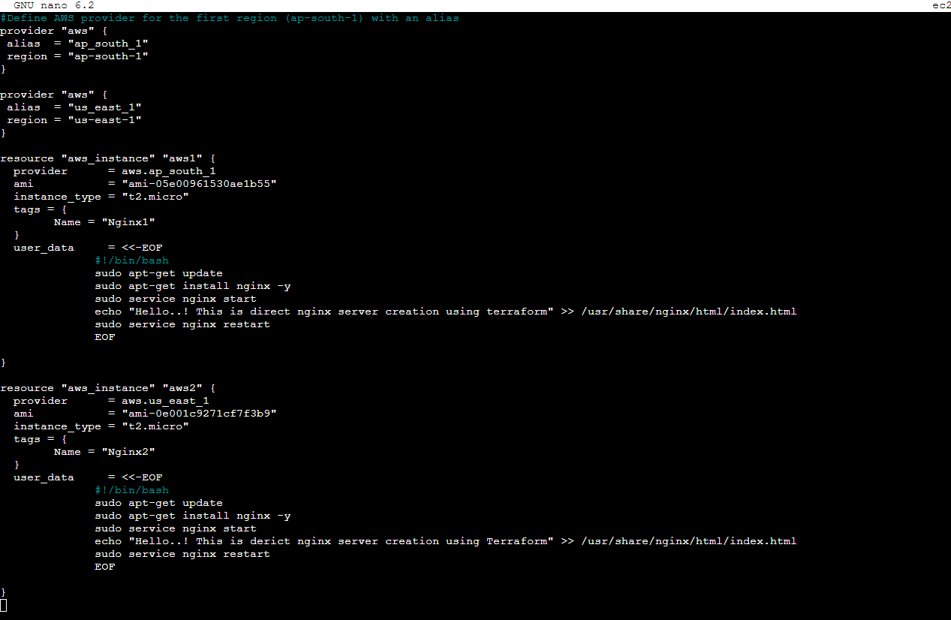

**5.Terraform file created and Terraform initialized in the directory**

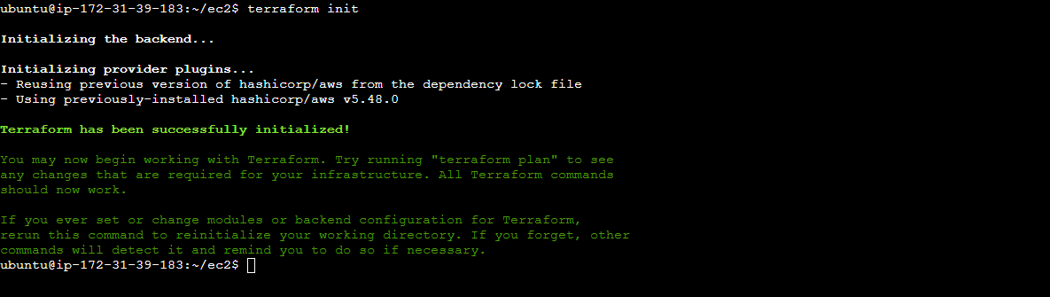

**6.First EC2 machine Plan**

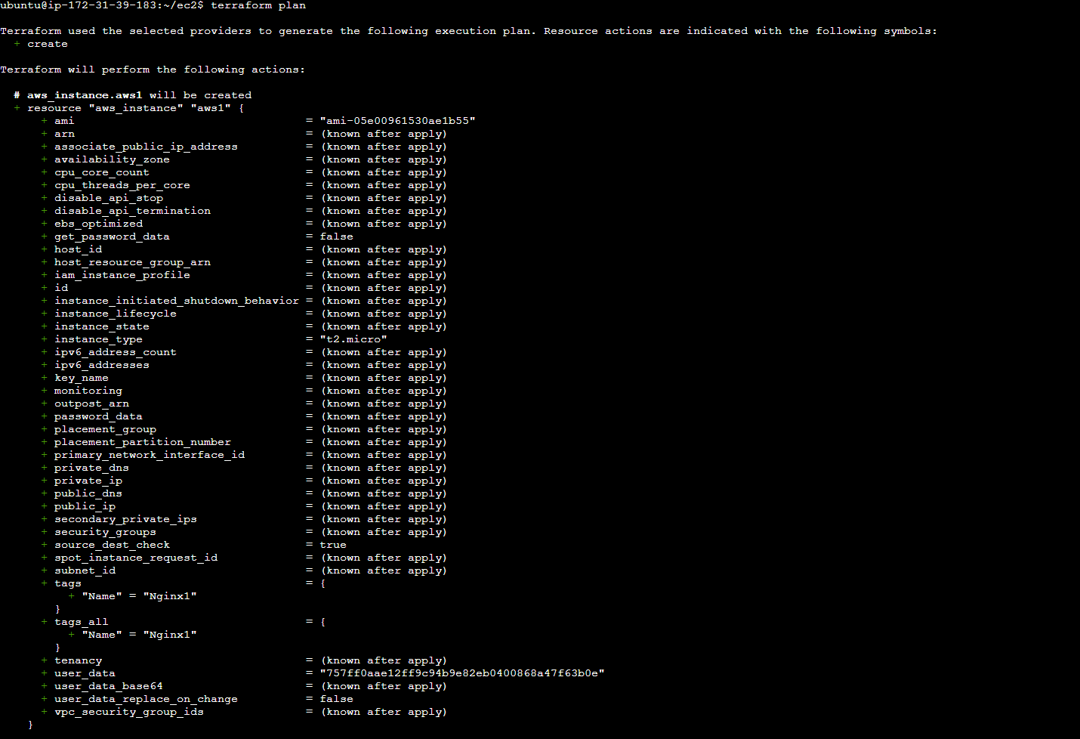

**7.Second EC2 machine Plan and Both Plan Added**

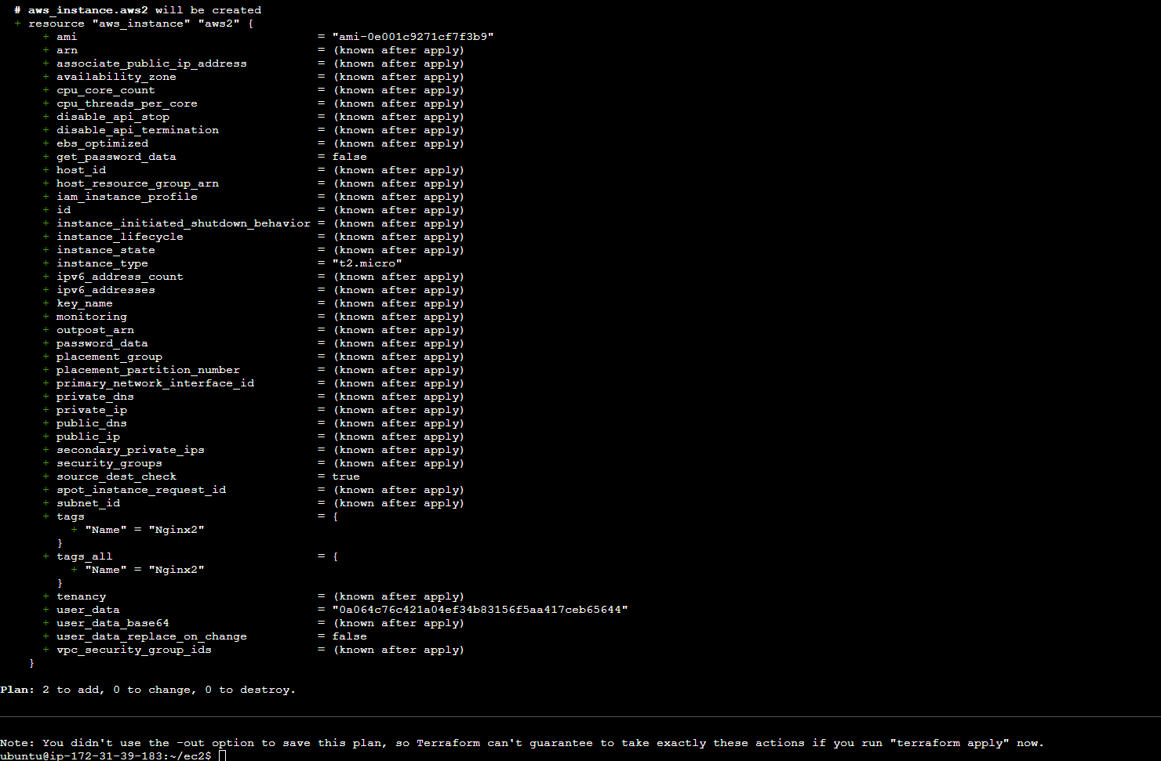

**8.Terraform Applied with the Script File**

First EC2 is creating:

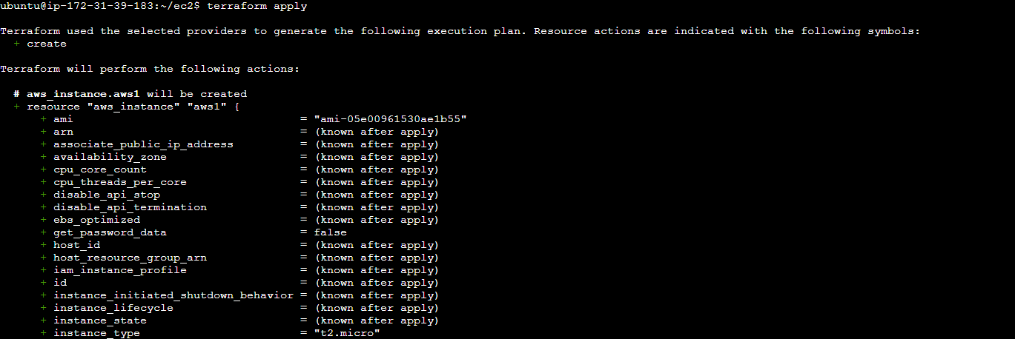

Second EC2 is creating:

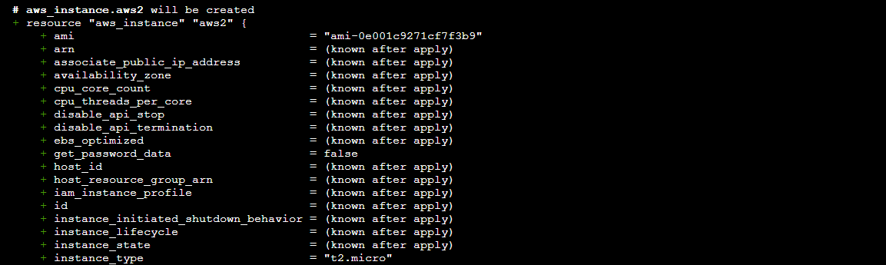

**9.Two EC2 machines are created in Two different Regions with Nginx server**

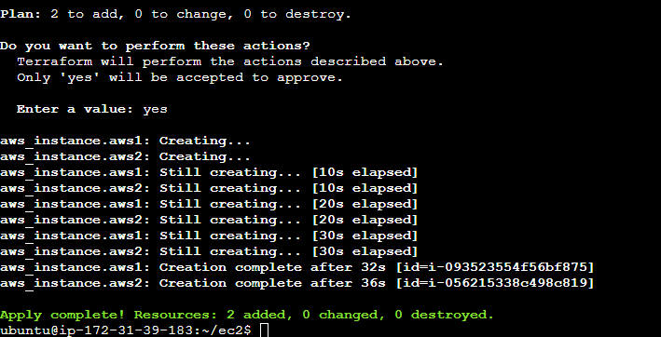

**10.First EC2 is Running in ap-south-1 Region with Nginx**

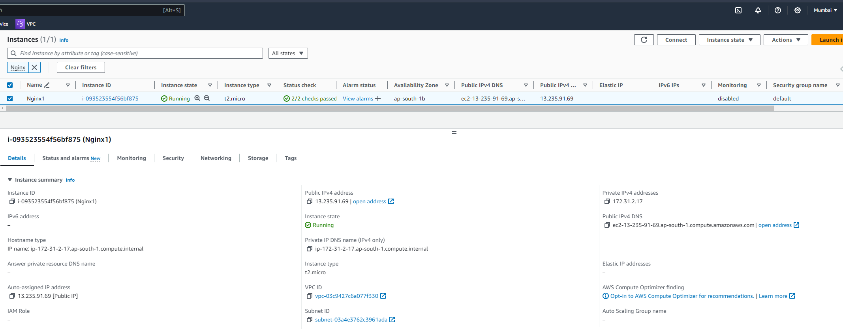

**11.Second EC2 is Running in us-east-1 Region with Nginx**

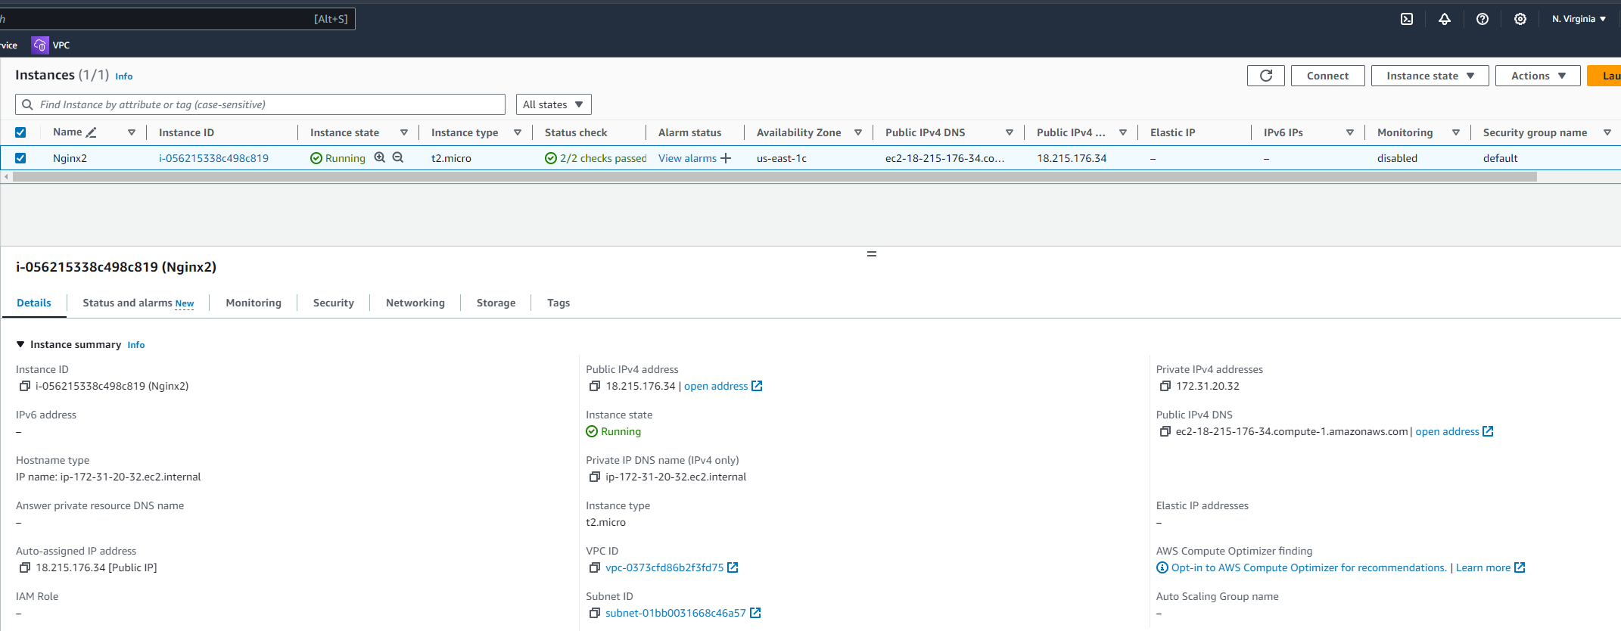

**12.First Nginx running in ap-south-1 region IP address**

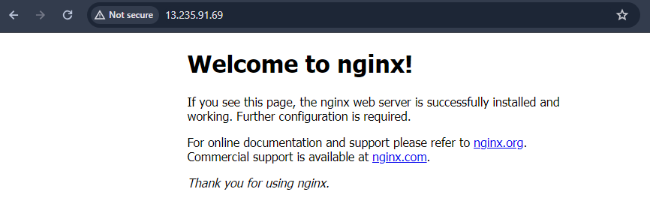

**13.Second Nginx running in us-east-1 region IP address**

